28.45:
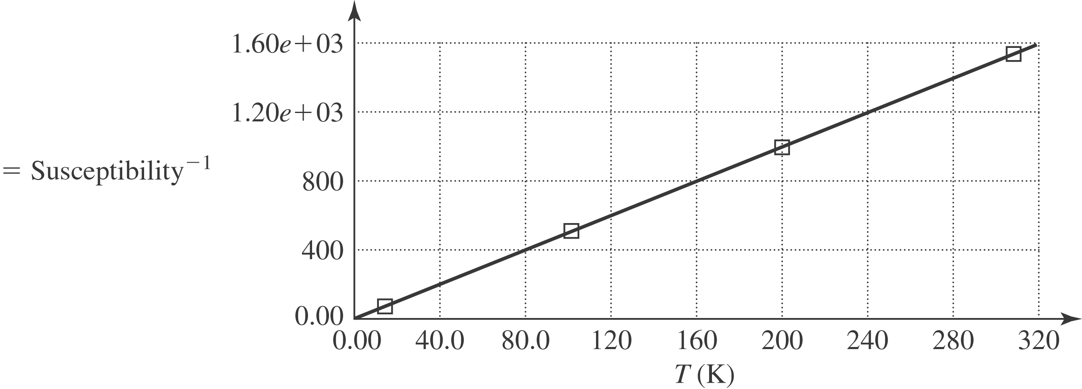

The material does obey Curie’s Law because we have a straight line for temperature against one over the magnetic susceptibility. The Curie constant from the graph is 